**Большакова В.А. ИСТ-111**

Схема страниц сайта с переходами представлена на рисунке 1.



*Рисунок 1. Схема сайта*

**Index.xhtml – начальная страница**



**Registration.xhtml – страница регистрации**



**Successfullreg.xhtml – страница после регистрации**

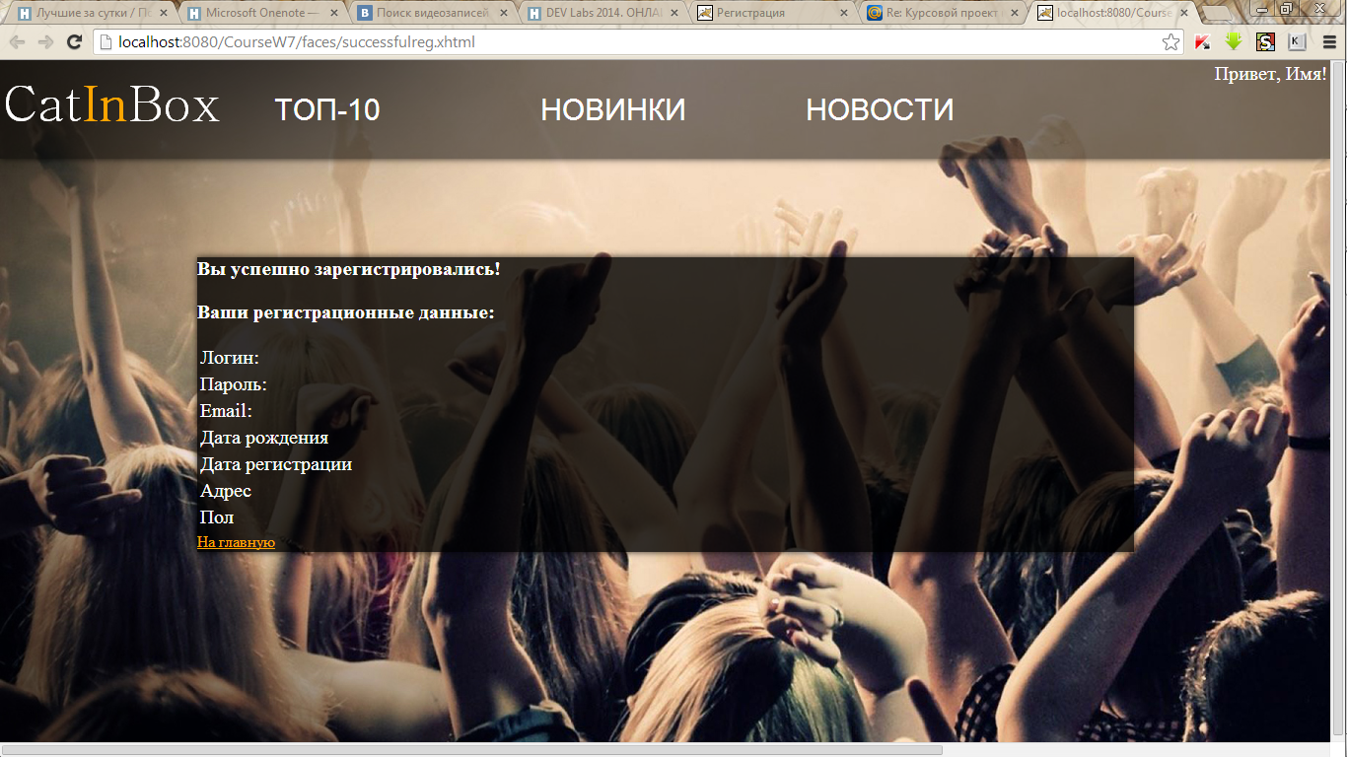

**newsname.xhtml – страница конкретной новости**



**Songname.xhtml – страница какой-то песни**



**Upload.xhtml – страница загрузки новой песни**



**Payment.xmtml**



**Бины**

**AlbumBean**

package beans;

import javax.faces.bean.ManagedBean;

import javax.faces.bean.SessionScoped;

import java.io.Serializable;

@ManagedBean

@SessionScoped

public class AlbumBean implements Serializable

{

private int albumID;

private String name;

private String genre;

private String duration;

private int year;

private int bandID;

public int getAlbumID() {

return albumID;

}

public void setAlbumID(int albumID) {

this.albumID = albumID;

}

public String getName() {

return name;

}

public void setName(String name) {

this.name = name;

}

public String getGenre() {

return genre;

}

public void setGenre(String genre) {

this.genre = genre;

}

public String getDuration() {

return duration;

}

public void setDuration(String duration) {

this.duration = duration;

}

public int getYear() {

return year;

}

public void setYear(int year) {

this.year = year;

}

public int getBandID() {

return bandID;

}

public void setBandID(int bandID) {

this.bandID = bandID;

}

}

**BandBean**

package beans;

import javax.faces.bean.ManagedBean;

import javax.faces.bean.SessionScoped;

import java.io.Serializable;

@ManagedBean

@SessionScoped

public class BandBean implements Serializable

{

private int bandID;

private String name;

private String genre;

private String description;

private String members;

public int getBandID() {

return bandID;

}

public void setBandID(int bandID) {

this.bandID = bandID;

}

public String getName() {

return name;

}

public void setName(String name) {

this.name = name;

}

public String getGenre() {

return genre;

}

public void setGenre(String genre) {

this.genre = genre;

}

public String getDescription() {

return description;

}

public void setDescription(String description) {

this.description = description;

}

public String getMembers() {

return members;

}

public void setMembers(String members) {

this.members = members;

}

}

**MessageBean**

package beans;

import javax.faces.bean.ManagedBean;

import javax.faces.bean.SessionScoped;

import java.io.Serializable;

import java.util.Date;

@ManagedBean

@SessionScoped

public class MessageBean implements Serializable

{

private int messageID;

private String message;

private Date date;

private int userID;

private int songID;

public int getMessageID() {

return messageID;

}

public void setMessageID(int messageID) {

this.messageID = messageID;

}

public String getMessage() {

return message;

}

public void setMessage(String message) {

this.message = message;

}

public Date getDate() {

return date;

}

public void setDate(Date date) {

this.date = date;

}

public int getUserID() {

return userID;

}

public void setUserID(int userID) {

this.userID = userID;

}

public int getSongID() {

return songID;

}

public void setSongID(int songID) {

this.songID = songID;

}

}

**NewsBean**

package beans;

import CRUD.CRUD;

import javax.faces.bean.ManagedBean;

import javax.faces.bean.SessionScoped;

import java.io.Serializable;

import java.util.ArrayList;

@ManagedBean

@SessionScoped

public class NewsBean

{

private int newsID;

private String newstext;

private String urlvideo;

private ArrayList<NewsBean> news;

private ArrayList<String> describes;

private int number;

private NewsBean chosenNew;

public void setChosenNew(NewsBean chosenNew) {

this.chosenNew = chosenNew;

}

public int getNumber() {

return number;

}

public void setNumber(int number) {

this.number = number;

}

public void setDescribes(ArrayList<String> describes) {

this.describes = describes;

}

public void setNews(ArrayList<NewsBean> news) {

this.news = news;

}

public int getNewsID() {

return newsID;

}

public void setNewsID(int newsID) {

this.newsID = newsID;

}

public String getNewstext() {

return newstext;

}

public void setNewstext(String newstext) {

this.newstext = newstext;

}

public String getUrlvideo() {

return urlvideo;

}

public void setUrlvideo(String urlvideo) {

this.urlvideo = urlvideo;

}

public ArrayList<NewsBean> getNews()

{

CRUD crud = new CRUD();

news = new ArrayList<NewsBean>();

news = crud.ReadNews();

return news;

}

public ArrayList<String> getDescribes()

{

int i = 0;

describes = new ArrayList<String>();

ArrayList<NewsBean> newsBeans;

newsBeans = getNews();

NewsBean somenew;

while (i!=6)

{

somenew = newsBeans.get(i);

describes.add(somenew.newstext.substring(0,somenew.newstext.indexOf('.')));

i++;

}

return describes;

}

public String newsRequest(int i)

{

setNumber(i);

return "newsPage.xhtml";

}

public NewsBean getChosenNew(int id) throws Exception {

NewsBean somenew;

CRUD crud = new CRUD();

somenew = crud.ReadNew(id);

setNewstext(somenew.newstext);

setUrlvideo(somenew.urlvideo);

return somenew;

}

}

**SongBean**

package beans;

import CRUD.CRUD;

import javax.faces.bean.ManagedBean;

import javax.faces.bean.SessionScoped;

import java.io.Serializable;

import java.util.ArrayList;

@ManagedBean

@SessionScoped

public class SongBean implements Serializable

{

private int songID;

private String name;

private int year;

private String genre;

private int bitrait;

private String duration;

private String size;

private double rait;

private String url;

private int userID;

private int albumID;

private String album;

private String artist;

private double cost;

public double getCost() {

return 12345;

}

public void setCost(double cost) {

this.cost = cost;

}

public String getArtist() {

return "artist";

}

public void setArtist(String artist) {

this.artist = artist;

}

public String getAlbum() {

return "album";

}

public void setAlbum(String album) {

this.album = album;

}

public int getSongID() {

return songID;

}

public void setSongID(int songID) {

this.songID = songID;

}

public String getName() {

return "name";

}

public void setName(String name) {

this.name = name;

}

public int getYear() {

return year;

}

public void setYear(int year) {

this.year = year;

}

public String getGenre() {

return genre;

}

public void setGenre(String genre) {

this.genre = genre;

}

public int getBitrait() {

return bitrait;

}

public void setBitrait(int bitrait) {

this.bitrait = bitrait;

}

public String getDuration() {

return duration;

}

public void setDuration(String duration) {

this.duration = duration;

}

public String getSize() {

return size;

}

public void setSize(String size) {

this.size = size;

}

public double getRait() {

return rait;

}

public void setRait(double rait) {

this.rait = rait;

}

public String getUrl() {

return url;

}

public void setUrl(String url) {

this.url = url;

}

public int getUserID() {

return userID;

}

public void setUserID(int userID) {

this.userID = userID;

}

public int getAlbumID() {

return albumID;

}

public void setAlbumID(int albumID) {

this.albumID = albumID;

}

public String successfulUpload() throws Exception {

CRUD crud = new CRUD();

SongBean songBean = new SongBean();

songBean.setName(name);

songBean.setAlbum(album);

songBean.setArtist(artist);

songBean.setGenre(genre);

if (crud.CreateSong(songBean))

{

return "successfulUpload.xhtml";

}

else return null;

}

}

**UserBean**

package beans;

import CRUD.CRUD;

import javax.faces.bean.ManagedBean;

import javax.faces.bean.SessionScoped;

import java.io.Serializable;

import java.sql.SQLException;

import java.util.Date;

@ManagedBean

@SessionScoped

public class UserBean implements Serializable

{

private int userID;

private String login;

private String password;

private String email;

private Date birthDate;

private String address;

private Date regDate;

private String gender;

private boolean isLogged = false;

public Date getBirthDate() {

return birthDate;

}

public void setBirthDate(Date birthDate) {

this.birthDate = birthDate;

}

public String getAddress() {

return address;

}

public void setAddress(String address) {

this.address = address;

}

public Date getRegDate() {

return regDate;

}

public void setRegDate(Date regDate) {

this.regDate = regDate;

}

public String getGender() {

return gender;

}

public void setGender(String gender) {

this.gender = gender;

}

public boolean isLogged() {

return isLogged;

}

public void setLogged(boolean logged) {

isLogged = logged;

}

public int getUserID() {

return userID;

}

public void setUserID(int userID) {

this.userID = userID;

}

public String getLogin() {

return login;

}

public void setLogin(String login) {

this.login = login;

}

public String getPassword() {

return password;

}

public void setPassword(String password) {

this.password = password;

}

public String getEmail() {

return email;

}

public void setEmail(String email) {

this.email = email;

}

public UserBean (){}

public String successfulreg() throws Exception {

CRUD crud = new CRUD();

UserBean userBean = new UserBean();

userBean.setLogin(login);

userBean.setPassword(password);

userBean.setEmail(email);

userBean.setAddress(address);

userBean.setBirthDate(birthDate);

if (birthDate==null) throw new Exception("Дата рождения null");

userBean.setGender(gender);

if (crud.Create(userBean))

{

userBean.setLogged(true);

return "successfulreg.xhtml";

}

else return null;

}

public String enter(String login, String password)

{

CRUD crud = new CRUD();

if (crud.checkUser(login, password))

{

setLogged(true);

return "main.xhtml";

}

else

{

setLogged(false);

return "main.xhtml";

}

}

public void exit()

{

setLogged(false);

}

}

**CardBean**

package beans;

import javax.faces.bean.ManagedBean;

import javax.faces.bean.SessionScoped;

import java.util.Date;

@ManagedBean

@SessionScoped

public class CardBean

{

private int cardId;

private String cardNum;

private Date valDate;

private String address;

private String CVC;

public int getCardId() {

return cardId;

}

public void setCardId(int cardId) {

this.cardId = cardId;

}

public String getCardNum() {

return "1234-5678-XXXX-9101";

}

public void setCardNum(String cardNum) {

this.cardNum = cardNum;

}

public Date getValDate() {

return valDate;

}

public void setValDate(Date valDate) {

this.valDate = valDate;

}

public String getAddress() {

return address;

}

public void setAddress(String address) {

this.address = address;

}

public String getCVC() {

return CVC;

}

public void setCVC(String CVC) {

this.CVC = CVC;

}

}

**DiscountBean**

package beans;

import javax.faces.bean.ManagedBean;

import javax.faces.bean.SessionScoped;

@ManagedBean

@SessionScoped

public class DiscountBean

{

private int discountId;

private String name;

private int discountSize;

private String discountSite;

public int getDiscountId() {

return discountId;

}

public void setDiscountId(int discountId) {

this.discountId = discountId;

}

public String getName() {

return name;

}

public void setName(String name) {

this.name = name;

}

public int getDiscountSize() {

return discountSize;

}

public void setDiscountSize(int discountSize) {

this.discountSize = discountSize;

}

public String getDiscountSite() {

return discountSite;

}

public void setDiscountSite(String discountSite) {

this.discountSite = discountSite;

}

}

**TransactionBean**

package beans;

import javax.faces.bean.ManagedBean;

import javax.faces.bean.SessionScoped;

import java.util.Date;

@ManagedBean

@SessionScoped

public class TransactionsBean

{

private int transactionId;

private Date trDate;

private boolean status;

private String amount;

private String name;

public int getTransactionId() {

return transactionId;

}

public void setTransactionId(int transactionId) {

this.transactionId = transactionId;

}

public Date getTrDate() {

return trDate;

}

public void setTrDate(Date trDate) {

this.trDate = trDate;

}

public boolean isStatus() {

return status;

}

public void setStatus(boolean status) {

this.status = status;

}

public String getAmount() {

return amount;

}

public void setAmount(String amount) {

this.amount = amount;

}

public String getName() {

return name;

}

public void setName(String name) {

this.name = name;

}

}